getParks()
ДАННЫЕ О ГОСУДАРСТВЕННЫХ ПРИРОДНЫХ ПАРКАХ КЫРГЫЗСКОЙ РЕСПУБЛИКИ
- URL: http://IP_SERVER/r1/central-server/GOV/YOUR_SUBSYSTEM_CODE/gaoos-reports/parks /
- Method:
Example GET /r1/INSTANCE/CLASS2/MEMBER2/SUBSYSTEM2/BARSERVICE/v1/bar/zyggy?quu=1
{serviceName}: parks
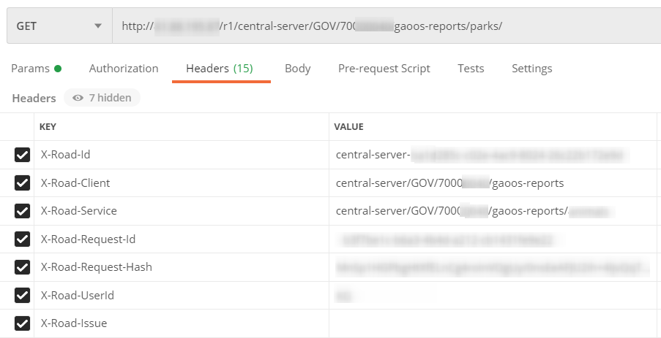
HTTP HEADERS:
X-Road specific headers
The response contains some X-Road specific headers that are set by the provider Security Server. The provider service SHOULD NOT set these headers since in that case they will be overwritten.
- X-Road-Client: Specifies the member/subsystem that is used as a service client
- X-Road-Service: Specifies the serviceId that is invoked by the service client
- X-Road-Id: Unique identifier for this message
- X-Road-Request-Hash: For responses, this field contains sha-512 encoded hash of the request message
- X-Road-Error: This header is provided in case there was an error processing the request and it occurred somewhere in X-Road (on the consumer or provider Security Server)
- X-Road-Request-Id: Unique identifier for the request
- X-Road-Client: INSTANCE/CLASS/MEMBER/SUBSYSTEM
- X-Road-Service: INSTANCE/CLASS/MEMBER/SUBSYSTEM/PETSTORE
- X-Road-Id: fa2e18a5-c2cb-4d09-b994-f57727f7c3fb
- X-Road-Request-Hash: 4c519cf0-0e5e-4ccf-b72b-8ed6fe289e6e
X-Road-Request-Id: f92591a3-6bf0-49b1-987b-0dd78c034cc3
Doc: https://github.com/nordic-institute/X-Road/blob/develop/doc/Protocols/pr-rest_x-road_message_protocol_for_rest.md#Ref_TERMS
Success Response:
HTTP status code:
200
Response body:
[
{
"name": "Каракол",
"actDate": "Постановление Правительства Кыргызской Республики от 15.04.1997 года № 225",
"location": "Иссык-Кульская область, Ак-Суйский район",
"purposeVisit": "Сохранение уникальных природных комплексов, ельников",
"square": "554"
}
]
Error Response:
HTTP status code:
400
Response body:
{
"type": "Client.BadRequest",
"message": "Ошибка! Отсутствует заголовок: X-Road-Request-Hash X-Road-UserId"
}
HTTP status code:
500
Response body:
{
"type": " Server.ServerProxy.DatabaseError ",
"message":"Error accessing database"
}
HTTP status code:
404
Response body:
NOT FOUND
#################################################################

